**Topic - Introduction to databases**

**Exercise**

**Problem Statement: There can be multiple customers, who can place multiple orders on the site. Now a sales person can handle these orders and will distribute into multiple sales persons (One order will be assigned to one salesperson only). So a sales person can have multiple orders of multiple customers.**

**Ques 1 - Create Database**

**Ans –**

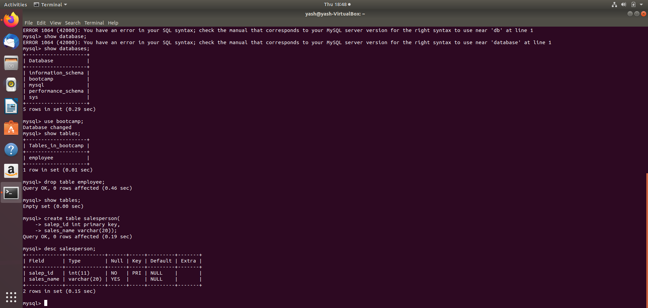

**Ques 2 - Design Schema**

**Ans –**

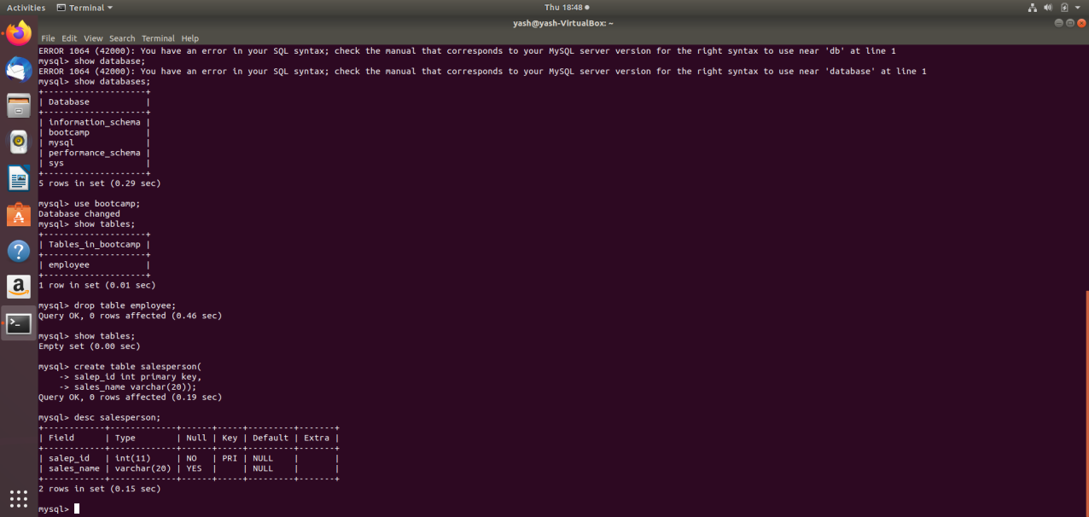



**Ques 3 - Create tables**

**Ans –**

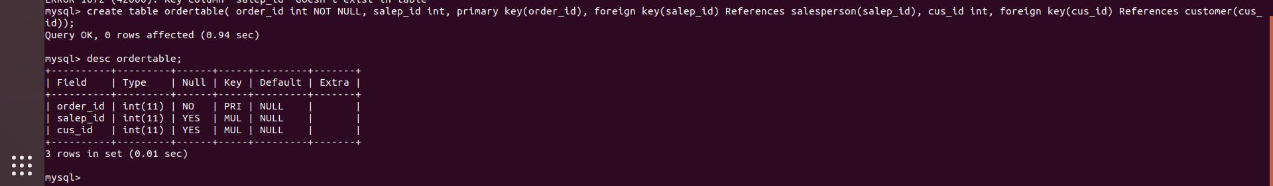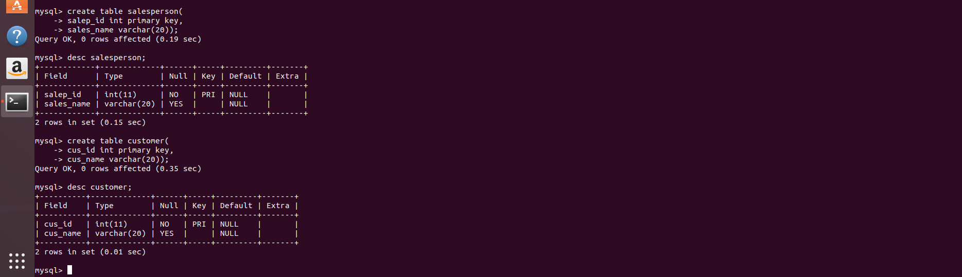

**Ques 4 - Insert sample data**

**Ans –**

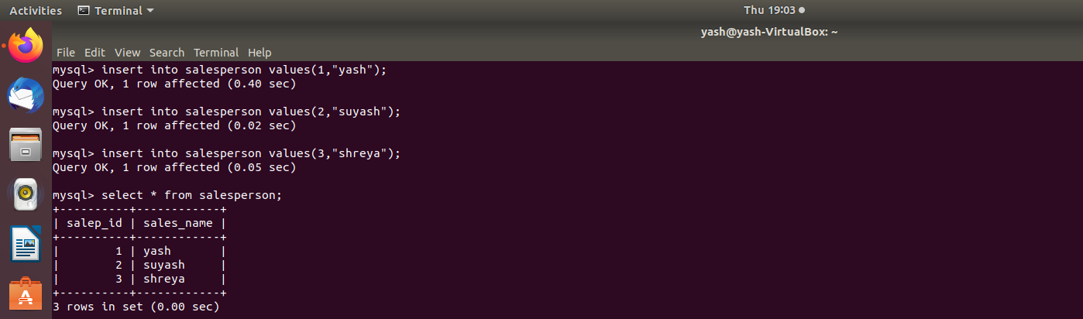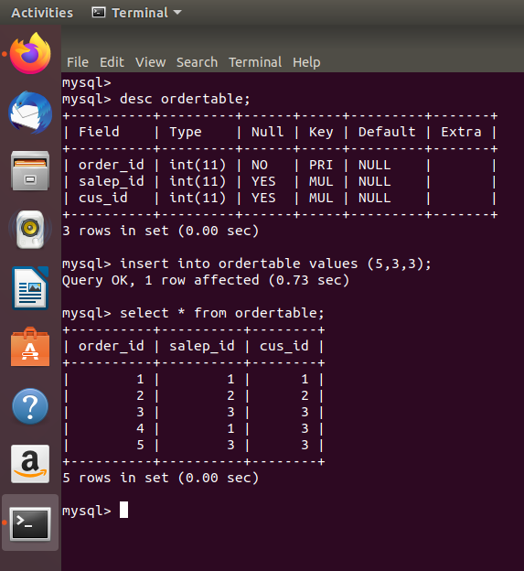

**Ques 5 - Find the sales person and have multiple orders.**

**Ans –**

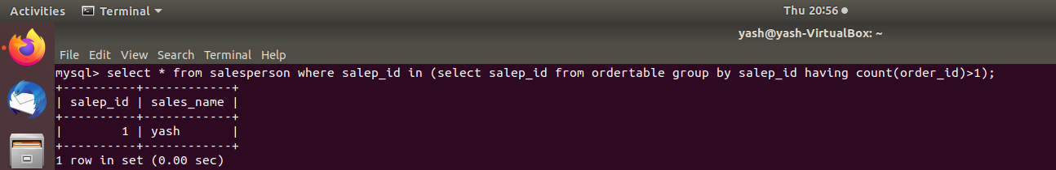

**Ques 6 - Find the all sales person details along with order details**

**Ans -**

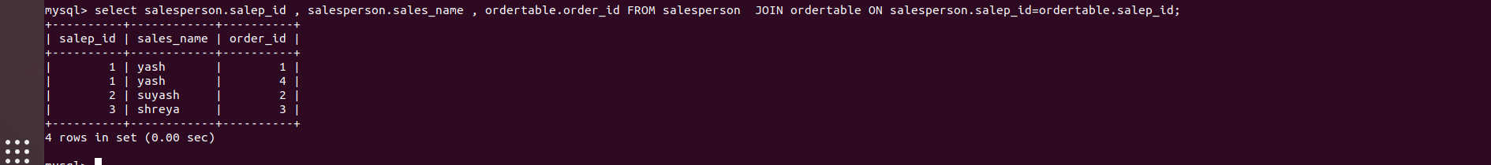

**Ques 7 - Create index**

**Ans -**

**Ques 8 - How to show index on a table**

**Ans -**

**Ques 9 - Find the order number, salesperson name, along with the customer to whom that order belongs to.**

**Ans -**

